
SHIRE HIGHLANDS EDUCATION DIVISION
2026 MALAWI SCHOOL CERTIFICATE OF EDUCATION MOCK EXAMINATION

GEOGRAPHY
Subject Number: M073/1
Tuesday, 24th March Time Allowed: 2½ Hours
8:00-10:30 am
PAPER 1
(100 marks)
MAP READING AND PHYSICAL GEOGRAPHY
Instructions:

- This paper contains 10 printed
pages. Please check.

- This paper has five questions. Answer the questions in the spaces provided.

- This paper has two sections, A and B.
- Section A comprises of three questions and candidates must answer all three questions.

- Section B comprises two questions and candidates must answer one question only.

- Write your name and school on top of the question paper.

- In the table provided on this page, tick against the question numbers you have answered.

Question number | Tick if answered | Do not write in these columns
1

2

3

4

5

© 2026 SHED MOCK Turn over
SECTION A (75 marks)
Instruction: Answer all questions in this section in the spaces provided

- Study the 1: 50 000 map extract for Madisi sheet 1333B3 and use it to answer questions that follow.
- Find the six- figure grid reference for Chakhaza Dispensary. ________________________________________________________________________ (2 marks)
- What geographical feature is found on grid reference 679145? ________________________________________________________________________ (2 marks)
- In which direction is Kasangadzi river flowing between eastings 64 and 67. _________________________________________________________________________ (1 mark)
- What is the highest altitude east of easting 66? _________________________________________________________________________ (1 mark)
- Which type of drainage pattern is common on the map. _________________________________________________________________________ (1 mark)
- Measure the distance of S116 from the junction with the main road to where it ends. Give your answer to the nearest kilometre. ________________________________________________________________________ (2 marks)
- Explain whether Chiwili CCAP and Mlambwe CCAP are intervisible. ________________________________________________________________________________________________________________________________________________________________________________________________________________________________________ (2 marks)
- Calculate the bearing of the borehole BH K120 (7020) from BH X182 (6919)

(2 marks)
- Find the approximate area of Mwagra Estate. Show your working.

(5 marks)

- Draw a cross-section along northing 13 between the tertiary road and the main road in grid box 6113 on the graph paper provided. On the cross-section indicate the rivers. (Take 1 cm to represent 50ft for the vertical scale)
(8 marks)
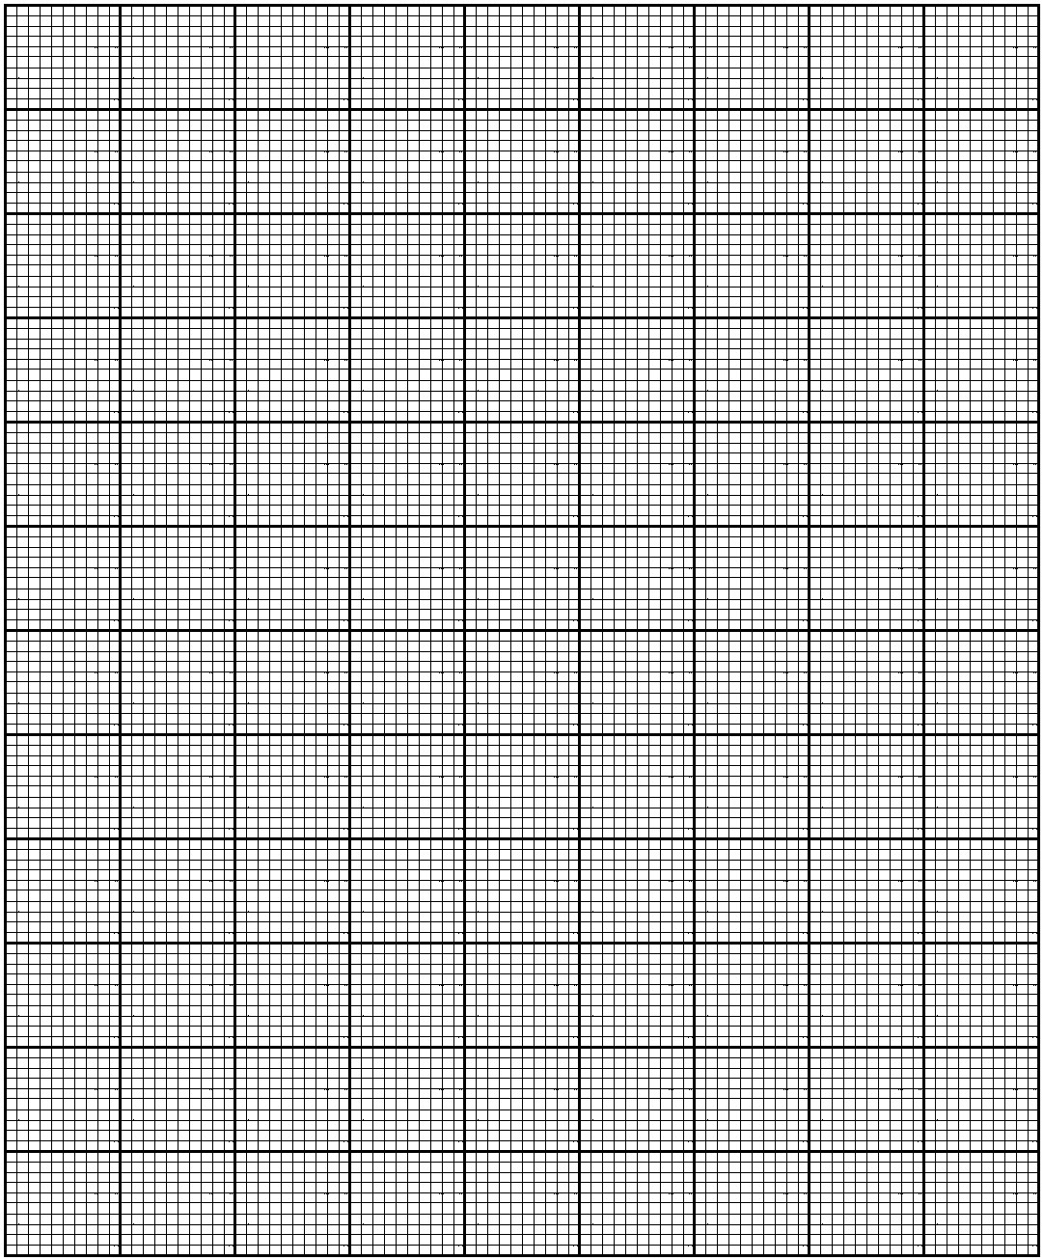
2. a. (i) What is an “earthquake”? ____________________________________________________________________________________________________________________________________________________ (2 marks)
(ii) Explain how faulting causes earthquakes. __________________________________________________________________________________________________________________________________________________________________________________________________________________________________ (2 marks)
(iii) Mention any two human activities which promote the occurrence of earth tremors. ____________________________________________________________________________________________________________________________________________________(2 marks)
b. (i) Give any two examples of solid precipitation. ______________________________________________________________________________________________________________________________________________________ (2 marks)
(ii) State any two characteristics of orographic rainfall. ______________________________________________________________________________________________________________________________________________________ (2 marks)
c. Figure 1 is a world map showing distribution of air masses.
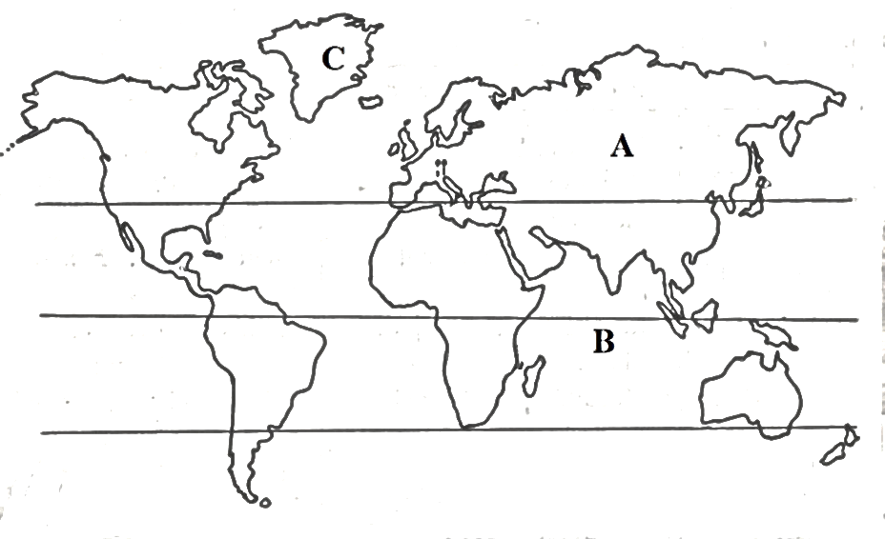
- Name the air masses found in regions labelled B and C
B ______________________________________________________________________ 1 mark
C ______________________________________________________________________ 1 mark
- State any two differences between the air masses found in regions labelled A and B. ______________________________________________________________________________________________________________________________________________________ (2 marks)
- Account for the absence of rainfall in regions lying under air mass C. _____________________________________________________________________________________________________________________________________________________________________________________________________________________________________ (3 marks)

d. Figure 2 is a diagram showing fronts. Use it to answer questions that follow:
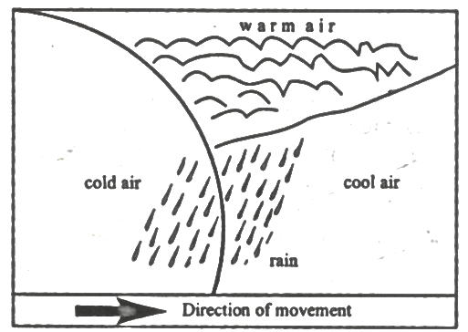
Figure 2
- Name the type of front. _______________________________________________________________________ (1 mark)
- Draw symbols to represent where your answer in d(i) is based.
(2 marks)
- Draw arrows to show the movement of warm air. (2 marks)
- (i) Define Air Pressure
____________________________________________________________________________________________________________________________________________________ (1 mark)
- Mention any two factors that affect air pressure. _________________________________________________________________________________________________________________________________________________ (2 marks)
3. a. (i) Give the two land masses which support the Jig Saw puzzle evidence in the theory of continental drift. ______________________________________________________________________________________________________________________________________________________(2 marks)
(ii) Briefly describe how Plate Tectonics Theory supports the Continental Drift Theory. ______________________________________________________________________________________________________________________________________________________(2 marks)
(iii) Mention any two economic importance of Rift valleys. ______________________________________________________________________________________________________________________________________________________(2 marks)
(iv) Explain any two-evidence supporting the concept of seafloor spreading. ________________________________________________________________________________________________________________________________________________________________________________________________________________________________________________________________________________________________________________(4 marks)
b. Figure 3 is a diagram of a plate boundary. Use it to answer the questions that follow:
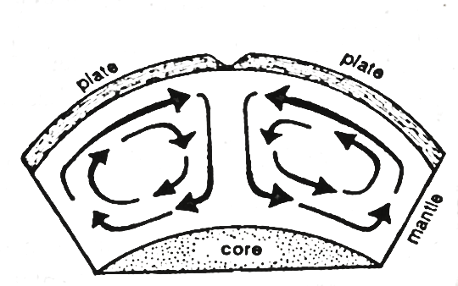
Figure 3
(i) Name the type of plate boundary. ______________________________________________________________________ (1 mark)
(jj) Mention any two geological features which are formed at this boundary. ____________________________________________________________________________________________________________________________________________________ (2 marks)
c. (i) Explain any two human causes of climate change. ________________________________________________________________________________________________________________________________________________________________________________________________________________________________________________________________________________________________________________ (4 marks)
(ii) Explain any two adaptation measures to climate change. ________________________________________________________________________________________________________________________________________________________________________________________________________________________________________________________________________________________________________________(4 marks)
(iii) Describe any two reasons why desertification is becoming a threat to Malawi. __________________________________________________________________________________________________________________________________________________________________________________________________________________________________________________________________________________________________ (4 marks)

SECTION B (25 marks)
Instruction: Answer any one question from this section.
4. a. The figure below is a table for a certain climatic region. Use it to answer the questions that follow:

Month | Jan | Feb | Mar | Apr | May | Jun | Jul | Aug | Sept | Oct | Nov | Dec
Temp°C | 25 | 25 | 26 | 27 | 25 | 25 | 26 | 25 | 26 | 27 | 25 | 25
Rainfal (mm) | 210 | 211 | 214 | 215 | 100 | 112 | 116 | 118 | 200 | 275 | 100 | 110

(i) Identify the type of climate for the table above. ____________________________________________________________________ (1 mark)
(ii) Name the type of vegetation which grows in the climate mentioned in 4 a. (i). ____________________________________________________________________ (1 mark)
(iii) Name any two areas in Africa which experience the climate mentioned in 4 a. (i). _______________________________________________________________________________________________________________________________________________ (2 marks)
(iv) Explain any two factors that hinders development in areas with climate mentioned in 4 a. (iii) _______________________________________________________________________________________________________________________________________________________________________________________________________________________________________________________________________________________________________ (4 marks)
b. Explain two reasons why the government of Malawi spends money on refuse disposals.
________________________________________________________________________________________________________________________________________________________________________________________________________________________________________________________________________________________________________________________ (4 marks)
c. With the aid of a well labelled diagram, explain how an aneroid barometer works

______________________________________________________________________________________________________________________________________________________________________________________________________________________________________________________________________________________________________________________________________________________________________________________________________________________________________________________________________________________________ (6 marks)
d. (i) Explain how igneous rock can change to sedimentary rock. _____________________________________________________________________________________________________________________________________________________________________________________________________________________________________________________________________________________________________________________________(4 marks)
(ii) Why are sedimentary rocks stratified. ___________________________________________________________________________________________________________________________________________________________(2 marks)
e. To which group do the cumulonimbus clouds belong. __________________________________________________________________________ (1 mark)
5. a. (i) Explain how global warming affects the amount of rainfall in an area. ___________________________________________________________________________________________________________________________________________________(2 marks)
(ii) Mention any two conditions necessary for the development of a Tropical cyclone. ____________________________________________________________________________________________________________________________________________________ (2 marks)
(iii) Describe the weather that is associated with the arrival of an eye during a tropical cyclone? ____________________________________________________________________________________________________________________________________________________ (2 marks)
(iv) Write the effect of the ITCZ in Malawi. ________________________________________________________________________________________________________________________________________________________________________________________________________________________________________________________________________________________________________________ (2 marks)

b. Figure 4 is world map. Use it to answer questions that follow:
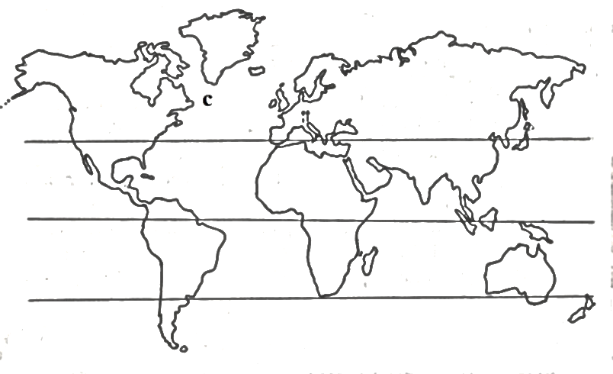

(i) Name the ocean currents that meet at C. ________________________________________________________________________________________________________________________________________________(2 marks)
(ii) Explain two effects of the meeting of the ocean currents mentioned in b (i) __________________________________________________________________________________________________________________________________________________ (4 marks)
The figure below shows a type of vegetation. Use it to answer the questions that follow
Figure 5
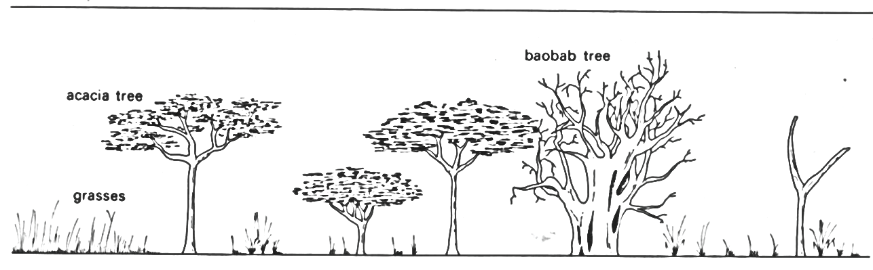
c. (i) Name the type of vegetation shown in the photograph. ______________________________________________________________________ (1 mark)
(ii) Describe any two characteristics of the vegetation type named in c (i) ________________________________________________________________________________________________________________________________________________________________________________________________________________________________________________________________________________________________________________ (4 marks)
(iii) Name any two countries in Africa where this type of vegetation is found. ____________________________________________________________________________________________________________________________________________________ (2 marks)
(iv) State any two factors which are likely to hinder development in the area where this type of vegetation is found. __________________________________________________________________________________________________________________________________________________ (2 marks)
(v) Explain one reason why desert plants have few or no leaves at all. ____________________________________________________________________________________________________________________________________________________ (2 marks)

END OF THE QUESTION PAPER
NB: This paper contains 10 printed pages.

